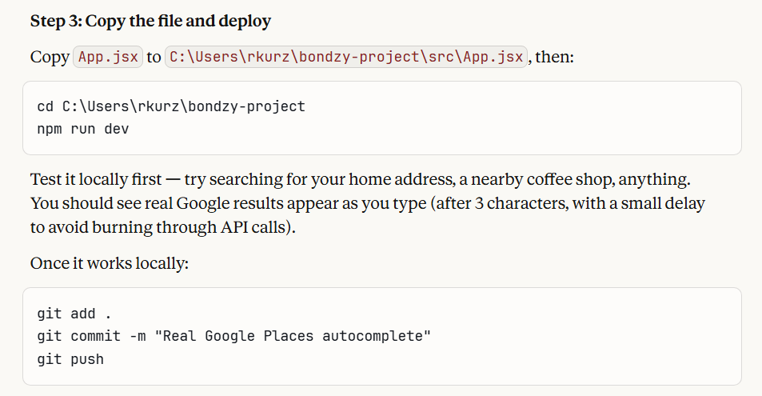

cd C:\Users\rkurz\bondzy-project
npm run dev

git add .
git commit -m "version information"
git push

